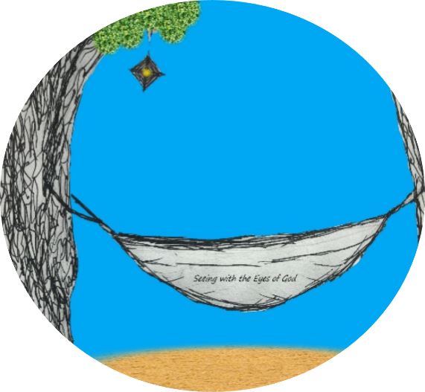

Are you Seeing with God’s Eyes?
It can be hard in today’s climate. That’s why we want to offer you an opportunity to relax and refocus this summer!
Throughout the summer months, we will be offering opportunities for households to refocus and refresh their spirits with our “Seeing with the Eyes of God” summer offering. This is for every household…for families, for grandparents, for those who just want to reconnect! It’s not VBS, it’s not faith formation, it’s a household #faithcation! A great way for you to bring God into every day!

