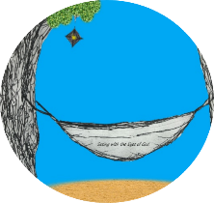
This week’s 5-Day Trip Planner JULY 5-JULY 11
FOR DETAILS on activities and MORE OPTIONS, VISIT:
click on website here
PICK ONE DESTINATION OR PICK THEM ALL! RELAX! IT’S OUR SUMMER JOURNEY OF FAITH…HOMESTYLE! You choose the route!
DAY 1 | Destination: Answer God’s Invitation “Come to Me”  Start the week by decorating a prayer box to hold intentions and thoughts you want to remember during your journey!
DAY 2 | Destination: See with God’s eyes this week by noticing the subtle signs God places before you! What has your faith revealed to you?  Read: http://www.usccb.org/bible/readings/070520.cfm  Send a prayerful message to God by trying our Fiery Tea Bag experiment! (CHILDREN MUST HAVE ADULT PRESENT) | 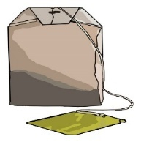
DAY 3 | Destination: Let go of your burdens and let God take over!  Remind yourself of that lifted weight by playing the Heavy Relay or doing a workout with some hand weights and then enjoy a light and airy snack by making some popcorn!
DAY 4 | Destination: Follow God’s Lead!  Collect school supplies or toiletries for an organization that serves the poor. THEY will need them now more than ever!  Visit the graves of veterans at a local cemetery and say a prayer for the burden they carried for our freedom | 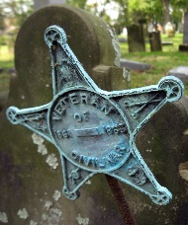
DAY 5 | Destination: Close your week by offering a prayer to the Holy Spirit that guides us and gives us courage for the journey of life! Here is run by St. Pope John Paul II  https://www.loyolapress.com/catholic-resources/prayer/contemporary-prayers/holy-spirit-and-seat-of-wisdom-by-pope-john-paul-ii/

