This week’s 5-Day Trip Planner JULY 12-JULY 18
FOR DETAILS on activities and MORE OPTIONS, VISIT:
click on website here
PICK ONE DESTINATION OR PICK THEM ALL! RELAX! IT’S OUR SUMMER JOURNEY OF FAITH…HOMESTYLE! You choose the route!
DAY 1 | Destination: Contemplate the mystery of God’s glory!  I SPY:  Take a walk, read the paper or surf the internet and identify the BEAUTY or GOOD NEWS…God is at work; can you see it?
DAY 2 | Destination: Discover the difference between rocky and fertile soil!  Try the snow powder experiment, plant some seeds to grow in your window or create an art project using a variety of household seeds! | 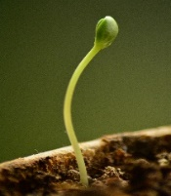
DAY 3 | Destination: Open your ears to God’s word!  Read this week’s scriptures http://www.usccb.org/bible/readings/071220.cfm and chat with someone about their message! Fortify yourself with a dirt cup pudding treat!
DAY 4 | Destination: Let God’s Kingdom grow through your good works!  Make some “just add water” soup mixes for neighbors, friends or those in need
DAY 5 | Destination: Close your week by offering a prayer for Christlikeness by Cardinal Newman  Prayer for Christlikeness

