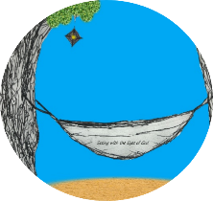
This week’s 5-Day Trip Planner JULY 19-JULY 25
FOR DETAILS on activities and MORE OPTIONS, VISIT:
click on website here
PICK ONE DESTINATION OR PICK THEM ALL! RELAX! IT’S OUR SUMMER JOURNEY OF FAITH…HOMESTYLE! You choose the route!
DAY 1 | Destination: Explore God’s Kingdom through parables: WHAT is God’s Kingdom like?  Spend some time with this week’s scriptures: http://www.usccb.org/bible/readings/071920.cfm  Can you create your own modern day parable connection? The kingdom of God is like….
DAY 2 | Destination: Discover how God can make big things out of tiny things like the mustard seed that packs a flavorful punch!  Yeast is also a tiny substance with big power. Try our balloon and yeast science experiment! | 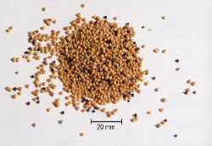
DAY 3 | Destination: Envision brighter days ahead with a spirit of HOPE  Create a hope tree in your home and fill it with your hopes for the future or messages of hope!
DAY 4 | Destination: Spread HOPE with a surprise of sunshine in someone’s mailbox!  Make a home-made card with a beautiful bright sunshine on the front; inside write a positive message. Send it as an anonymous surprise to a friend or family member or send some messages of hope along with donations to a shelter or soup kitchen!
DAY 5 | Destination: End your week in prayer by praying the Act of Hope  Act of Hope

