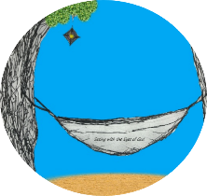
This week’s 5-Day Trip Planner AUG 2-AUG 8
FOR DETAILS on activities and MORE OPTIONS, VISIT:
click on website here
PICK ONE DESTINATION OR PICK THEM ALL! RELAX! IT’S OUR SUMMER JOURNEY OF FAITH…HOMESTYLE! You choose the route!
DAY 1 | Destination: Count your blessings  God does so much to enrich our lives every day! Today, make some Sharing Soup! Draw a soup pot and include your “ingredients”, which are all of the things that God has done for you. Don’t forget to write your recipe, which is all of the good things that you can do for others!
DAY 2 | Destination: Think about your personal growth  We are constantly growing in our faith and our understanding of God’s love for us. Complete this fun science experiment to make ice grow! https://teachpreschool.org/2014/07/18/fun-with-frozen-making-ice-grow/
DAY 3 | Destination: Enjoy time to grow relationships  Put together a “build your own sundae bar” and enjoy some treat time with family or friends!
DAY 4 | Destination: Care for your body by enjoying some physical activity  Create your own obstacle course by using items you have around your house! Do you have someone else in your family that you want to compete with? Everyone make your own obstacle course and race against each other!
DAY 5 | Destination: End your week by praising God for all that he has shown you or helped you to work through!

