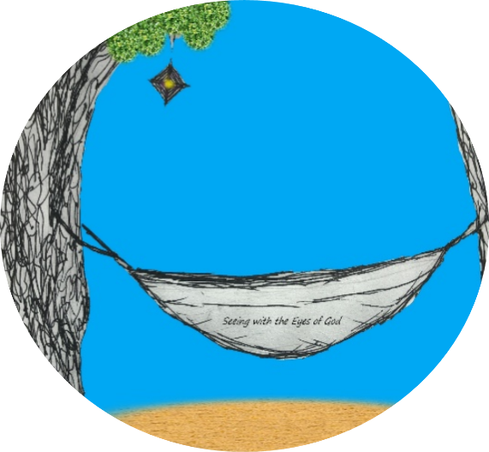

SUMMER FAMILY FAITH JOURNEY
Trail Mix Blessing Prayer

Let us pray:
God of Summertime fun,
You have created us and blessed us with many people who love and care for us.
You fill the earth with so many awesome things.

As we begin this journey, OPEN OUR EYES to SEE the world—
all creation, every adventure and all the people we encounter,
with YOUR EYES.

Let’s start by remembering. We take a moment to think of all who bless us each day on our journey of life.
(Name some of the people for whom you are thankful)

And we bless this trail mix—our snack for the journey.
Food from the earth prepared by human hands and shared with love:

For the gift of Pineapple—a symbol of hospitality and welcome.

Let us pray in gratitude for the fruits of the earth. May the sweet pieces of pineapple remind us to always to welcome others with the kindness that Jesus showed. May our care for all of creation and compassion for all living things: plants, animals and people, sprinkle our path with sweetness and love.

+Help me to SEE with your EYES, Lord.

For the gift of M&Ms
Let us praise God for all the sweet moments we will have on our summer journey and thank God for the daily reminders of God’s love. May the sweet moments make the disappointments and hardships on life’s journey bearable.

+ Help me to SEE with your EYES, Lord.

For the gift of Popcorn
Inside every piece of popcorn we find a kernel at the center, may we always keep Jesus as THE KERNEL of our lives. Let us thank God for the people and moments that have helped us to POP into new life.

+ Help me to SEE with your EYES, Lord.

For the gift of spicy Pumpkin Seeds
This treat begins as one seed buried in the ground. With the care of the gardener, the gift of the earth and the refreshing rains, it brings forth an abundant harvest of great pumpkins. From the center of the pumpkin, many seeds are scooped out, cleaned, seasoned, and baked. They become a tasty treat. May the seeds of God’s love, the soil of our lives, watered with the love of the Holy Spirit produce in us abundant fruits—peace, patience, joy and kindness. Let us pray in thanksgiving for all who care for us helping us to grow and become a gift for others.

+ Help me to SEE with your EYES, Lord.

Lord, bless the trail mix snack provided for us. Bless those who have prepared it and all those who will enjoy it. Bless all who will participate in this summer family faith journey. Keep us safe and help us to remember to be thankful every day for the gifts you share with us.

AMEN

