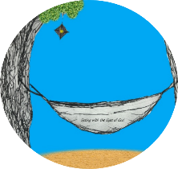
This week’s 5-Day Trip Planner AUG 23 -AUG 29
FOR DETAILS on activities and MORE OPTIONS, VISIT:
click on website here
PICK ONE DESTINATION OR PICK THEM ALL! RELAX! IT’S OUR SUMMER JOURNEY OF FAITH…HOMESTYLE! You choose the route!
DAY 1 | Destination: Think about your foundation in faith  Create your own Oobleck! An oobleck is a solid and a liquid. You need a solid foundation, but you also need to be flexible! What you need: 2 cups Corn Starch and 1 cup of water. What you do: Mix together and PLAY! | 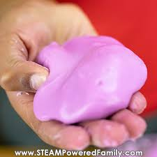
DAY 2 | Destination: Use God’s creation to make a masterpiece  Find some rocks of all different shapes and sizes! Make pebble art. You could make your family, an animal or a fun scene! Be creative! Glue it to cardstock or just take a picture of your creation! | 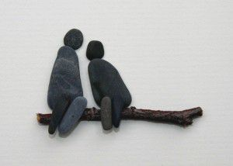
DAY 3 | Destination: Dance for joy!  We interrupt this week for a song and dance break!  https://www.youtube.com/watch?v=mO_YzyHp30k
DAY 4 | Destination: Learn more about yourself or those you love!  Create your own puzzle! Cut out the puzzle pieces and attach each piece. As you finish, decorate each piece! Click the document below for additional activities with your puzzle!  Click here
DAY 5 | Destination: Be a creator!  Make your own Rock Candy! You will need plenty of patience- It could take up to 7 days to create!  https://www.thespruceeats.com/rock-candy-521016

