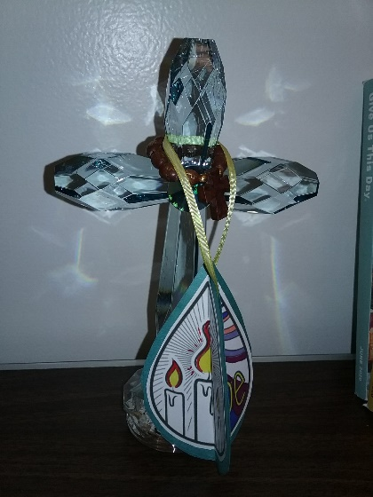
CREATE ORNAMENTS OF HOPE
Each household member can make one or two each and name what their hope is. Place a small tree branch in jar or vase with stone in the base to hold the branch. Hang ornaments on the branch.
Materials needed – ornament design (provided), stick glue, or double -sided invisible tape, thread or ribbon., scissors, no-bleed color sharpies or markers, gel pens, crayons. Color construction paper for additional effect.

1.Cut out the three parts to the paper ornament.
2.Write your hope on the paper that has “I am hopefully waiting for…”
3.Color the other two paper ornament pieces.
4.Fold the three ornament pieces, with the back of each facing outward, length wise down the middle
5.Glue/Tape the half the backs of two ornaments together
6.Cut string or ribbon long enough to hang the ornament. Fold in half. Tie the ends
7.With the tied ends in the ornament, glue/tape it to the two halves you just glued/taped.
8.Glue/tape the back of the remaining ornament piece to the backs of the other two pieces to create a three-sided ornament

Variations – To give your ornament an added effect add three construction paper backings in the shape of the ornament piece. Make each construction paper cutout about 1/8’ larger the ornament design cutout (see picture of ornament hanging on cross.
Use blank paper to make your own ornament design.

CREATE ORNAMENTS OF HOPE - © 2019 Illustrated Ministry, LLC. All Rights Reserved. illustratedministry.com May be reproduced for congregational and personal use only, provided each copy carries this notice.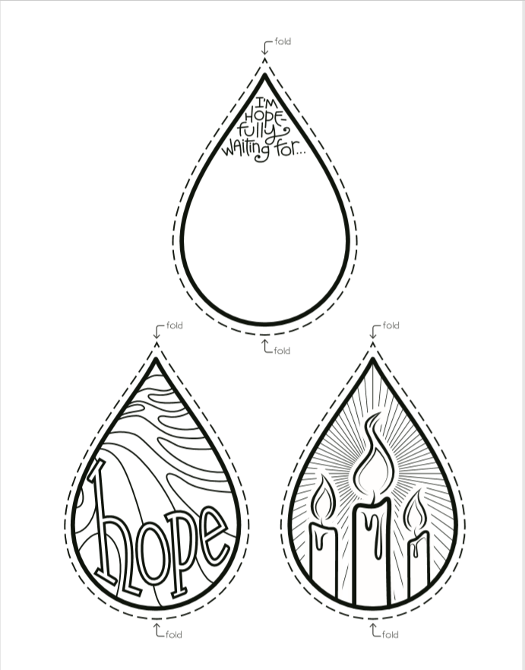
HOW TO CREATE ORNAMENTS OF HOPE
