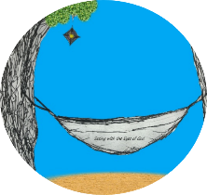
This week’s 5-Day Trip Planner AUG 16 -AUG 22
FOR DETAILS on activities and MORE OPTIONS, VISIT:
click on website here
PICK ONE DESTINATION OR PICK THEM ALL! RELAX! IT’S OUR SUMMER JOURNEY OF FAITH…HOMESTYLE! You choose the route!
DAY 1 | Destination: Be amazed at what is possible with Christ!  None of us thought that a candle would stay lit underwater, just as no one thought that someone could be healed! But with Jesus and faith, anything is possible! Try this experiment and see! https://www.youtube.com/watch?v=8XSzJibma1s
DAY 2 | Destination: Improve your prayer life  Paint a rock with the word PRAY on it and leave it on your pillow. Every night when you head to bed, you will be reminded to spend some time sharing gratitude, intentions and quiet reflection over your day with God. | 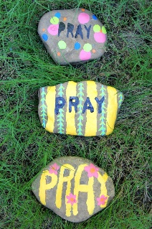
DAY 3 | Destination: Pray and Play!  There are many different ways to pray. Let’s play and pray today! Grab a beach ball and have fun with this beach ball prayer!  https://www.raisingprayerfulkids.com/post/beach-ball-prayers | 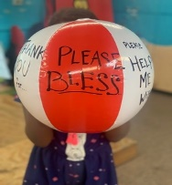
DAY 4 | Destination: Reach out  Today, call one someone you have been praying for lately! You can also visit the cemetery of family and friends and let your departed loved ones know that you are praying for them too!
DAY 5 | Destination: Let your light shine!  How will you let your light shine for others today?  This Little Light of Mine- https://www.youtube.com/watch?v=ty9bZXN4uWA

